**Course: C339 Data Fundamentals**

**Date: February 24, 2023**

**Title: Regular expressions and Indexing**

**REGEXP_SUBSTR function**

[**https://www.javatpoint.com/mysql-regexp-substr-function**](https://www.javatpoint.com/mysql-regexp-substr-function)

[**https://dev.mysql.com/doc/refman/8.0/en/regexp.html#function_regexp-replace**](https://dev.mysql.com/doc/refman/8.0/en/regexp.html#function_regexp-replace)

**Creating and deleting indexes**

Indexes are used to retrieve data from the database more quickly than otherwise. The users cannot see the indexes, they are just used to speed up searches/queries.

Hence, indexes are created based on queries or as per required.

The CREATE INDEX statement is used to create indexes in tables.

There are two types of CREATE INDEX statements in mySQL:

1. CREATE INDEX: Creates an index on a table. Duplicate indexes are allowed.
2. CREATE UNIQUE INDEX: Creates a unique index on a table. Duplicate values are not allowed.

The same way we can create indexes, we can delete indexes. This is done by using the DROP INDEX statement following an ALTER TABLE statement.

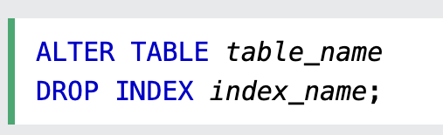

**ACID Compliance**

| Atomicity | Follows the “all or nothing” rule. If one action in the transaction fails, then the entire transaction fails. An atomic transaction never partially succeeds. |
| --- | --- |
| Consistency | consistency is about ensuring the information in the database is always meaningful |
| Isolation |  |
| Durability |  |